**DAILY ONLINE ACTIVITIES SUMMARY**

|  |  |  |  |  |  |  |  |  |
| --- | --- | --- | --- | --- | --- | --- | --- | --- |
| **Date:** | **08-06-2020** | | | | | **Name:** | **pallavi** | |
| **Sem & Sec** | **6th A** | | | | | **USN:** | **4al17cs056** | |
| **Online Test Summary** | | | | | | | | |
| **Subject** | | **CNSC** | | | | | | |
| **Max. Marks** | | **60** | | **Score** | | | **30** | |
| **Certification Course Summary** | | | | | | | | |
| **Course** | **Python for machine learning** | | | | | | | |
| **Certificate Provider** | | | **Great learning academy** | | **Duration** | | | **5hr** |
| **Coding Challenges** | | | | | | | | |
| **Problem Statement:**  1.Given a number N, the task is to check if this number can be represented as the difference of two perfect squares or not.  2. C Program to Generate All the Set Partitions of n Numbers Beginning from 1 and so on  3.n this program, we will create a singly linked list and delete a node from the middle of the list.  4.Write a python function that will take a string and checks whether it is a palindrome or not. Return If it a palindrome, print true else print false | | | | | | | | |
| **Status:completed** | | | | | | | | |
| **Uploaded the report in Github** | | | | | **yes** | | | |
| **If yes Repository name** | | | | | <https://github.com/pallavi056/DAILY_STATUS> | | | |
| **Uploaded the report in slack** | | | | | **yes** | | | |

Oline Test Details:

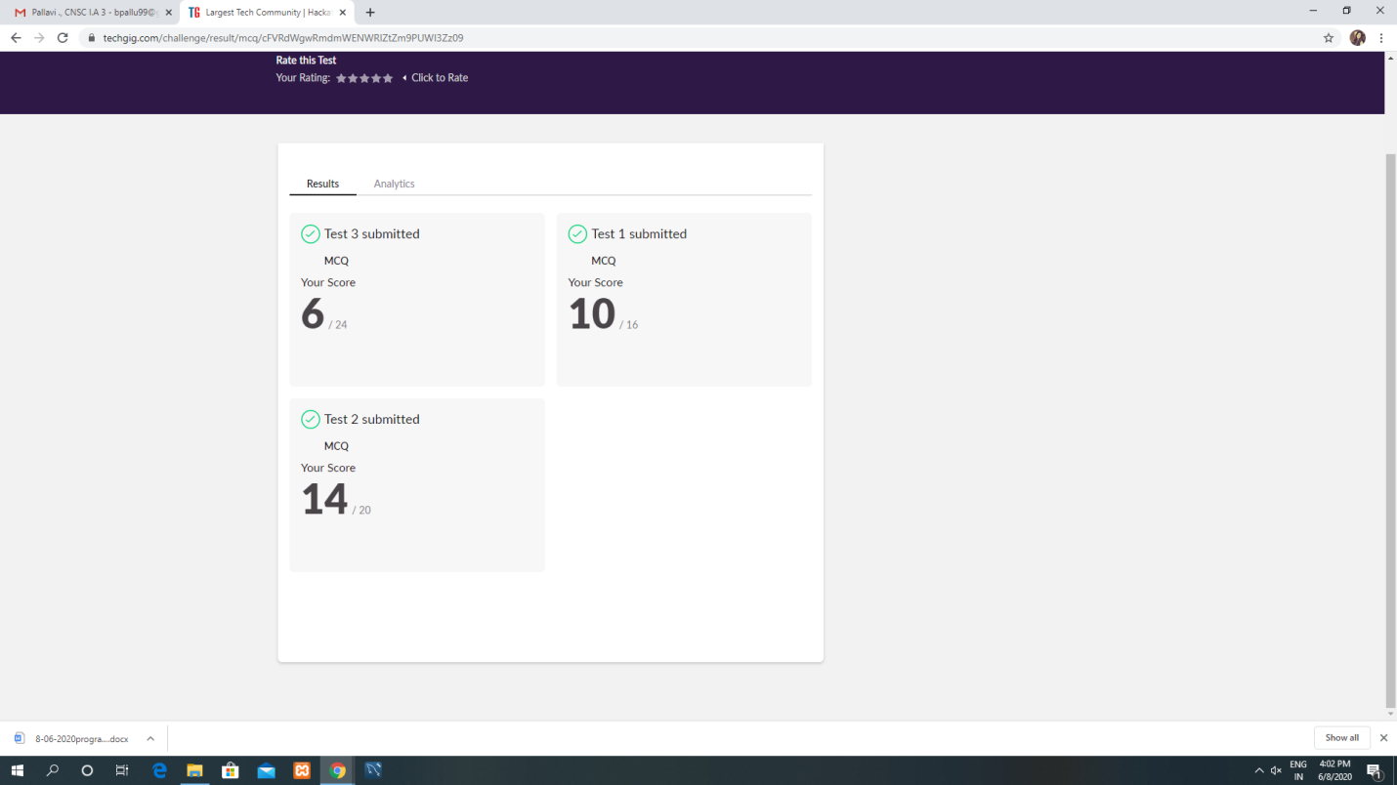

Certification Course Details:

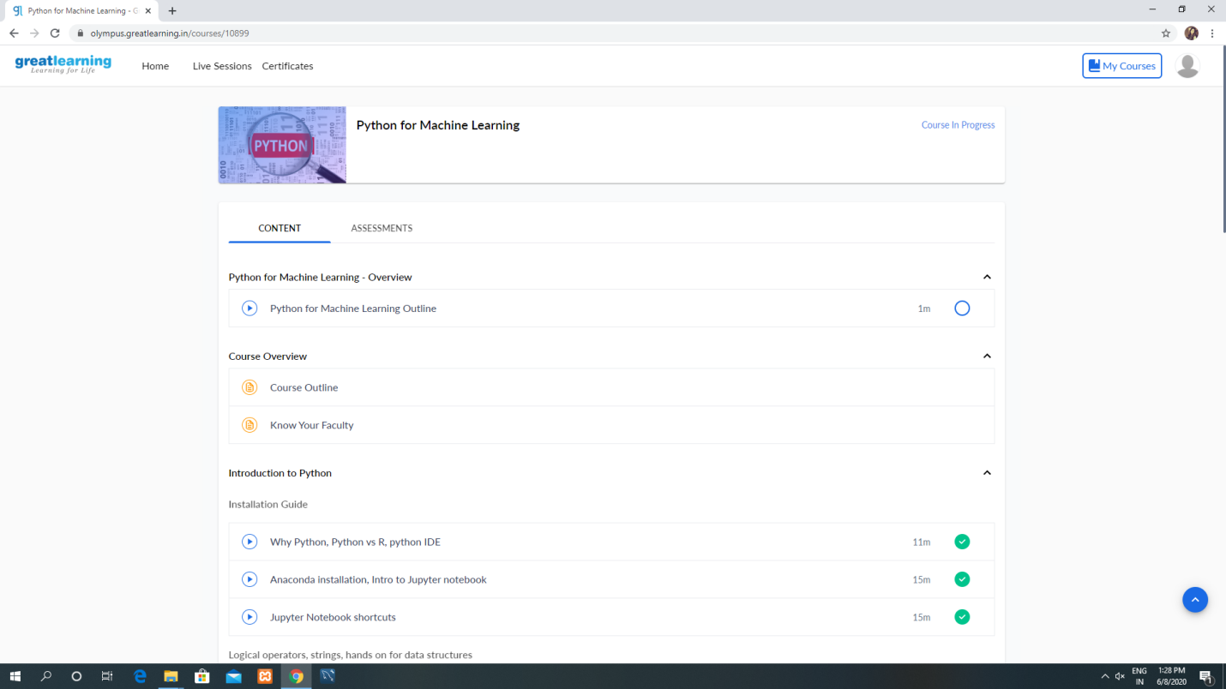

Coding Challenges Details: